Html 5 Structure:
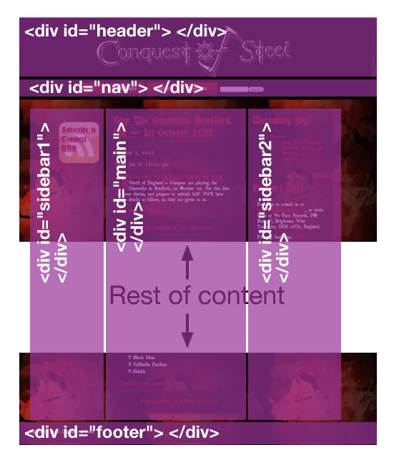
Code:

<body>

<div id="header">
<!-- header content goes in here -->
</div>

<div id="nav">
<!-- navigation menu goes in here -->
</div>

<div id="sidebar1">
<!-- sidebar content goes in here -->
</div>

<div id="main">
<!-- main page content goes in here -->
</div>

<div id="sidebar2">
<!-- sidebar content goes in here -->
</div>

<div id="footer">
<!-- footer content goes in here -->
</div>

</body>

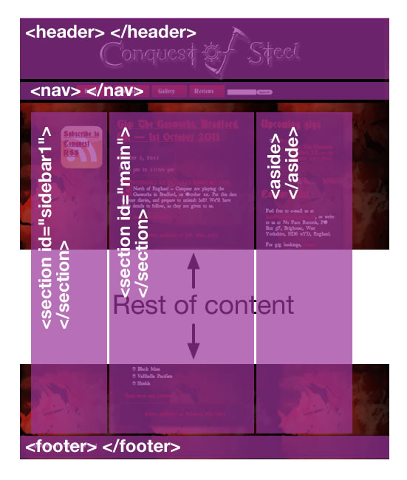
<body>

<header>
<!-- header content goes in here -->
</header>

<nav>
<!-- navigation menu goes in here -->
</nav>

<section id="sidebar1">
<!-- sidebar content goes in here -->
</section>

<section id="main">
<!-- main page content goes in here -->
</section>

<aside>
<!-- aside content goes in here -->
</aside>

<footer>
<!-- footer content goes in here -->
</footer>

</body>

